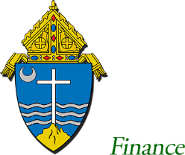
Office of
Charitable Giving

 | Diocese of Rockford
 | 555 Colman Center Dr.
 | P.O. Box 7044 | (815) 399-4300
 | Rockford, IL 61125 | Fax: (815) 399-5657

June 1, 2021

Mr. & Mrs. DONOR NAME
ADDRESS
CITY, STATE ZIP

Dear Mr. & Mrs. DONOR NAME,

Thank you for recommending that we receive a generous grant of $300.00 through the NAME OF Charitable Fund at FINANCIAL COMPANY. We have received the grant and the funds will be designated to the 2021 Diocesan Appeal.

On Behalf Of: Mr. & Mrs. DONOR NAME
Duid # ######

Designation: 2021 National Appeal

Parish: PARISH NAME, CITY

Thank you again and may God richly bless you for your generosity.

Sincerely,

Claudia Broman
Director

